Association Rules and Lift Analysis
Task 3
Kiara Angelys Gänger
Western Governor University
D212 | Data Mining II

Scenario 1
One of the most critical factors in customer relationship management that directly affects a company’s long-term profitability is understanding the customers. When a company can better understand its customers’ characteristics, it is better able to target products and marketing campaigns for customers, resulting in better profits for the company in the long term.
You are an analyst for a telecommunications company that wants to better understand the characteristics of its customers. You have been asked to perform a market basket analysis to analyze customer data to identify key associations of your customer purchases, ultimately enabling better business and strategic decision-making.

Part I: Research Question

Purpose of Report

Question
What combinations of items do customers frequently purchase together?

Goal
My goal is to identify patterns in customer purchases that can inform future marketing strategies and product placement in the company’s online store.

Part II: Market Basket Justification

Reasons For Market Basket Analysis

Explain How Market Basket Analyzes the Data:
Market basket analysis (MBA) identifies relationships between items that customers frequently purchase together. It helps companies better understand customer buying behaviors by examining associations between products (Staff, 2024). Market Basket will analyze the data by identifying the customer’s purchase history. Apriori algorithm will then extract the items that are frequently bought together.
My expected outcomes will be association rules that provide insights into item combinations. For example, if a customer buys a USB-C charger, they may also buy a USB-C to HDMI adapter. These item relationships will help companies on how to display and place items in stores. Since those two items are frequently bought together, it would make sense to place them next to each other.

Example of Transactions:
One example of a transaction in the dataset is row 249:
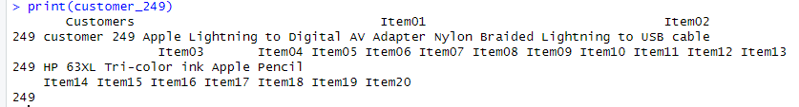
This customer has purchased in either one trip or multiple a Apple Lightning to Digital AV Adapter, Nylon Braided Lightning to USB cable, HP 63XL Tri-color ink and a Apple Pencil.

Assumption of Market Basket Analysis
One fundamental assumption of market basket analysis is that the presence of one item in a transaction increases the likelihood of another item being included in the same transaction (R Market Basket Analysis using Apriori Examples, 2018). This assumption helps identify associations between products based on historical purchase data, which can help businesses understand product pairings and can design promotion. For example, if 70% of customers who buy Beer also buy diapers, they can run a buy a six pack and get diapers 50% off.

Part III: Data Preparation and Analysis

Prepare and Perform Market Basket Analysis

Transform the Data
To transform and prepare the data I needed to remove all the empty rows and renumber them. Then I checked for duplicates. Here is where things got a little tricky for me. Given that there are no customer id or unique numbers to identify each transaction, it made it hard to confirm if the transactions were in fact duplicates. Since customers can buy the same things as others and the purpose of MBA is to find patterns in items that are frequently bought together. So, I went ahead and skipped dropping the all the rows that popped up as duplicates and proceeded to transform the dataset into a transactions object
After transforming the dataset into a transaction object and reviewing the summary to see how many transactions there were I ran the Apriori Algorithm to discover the association rules. Once i have generated the rules, I was able to to see the values for support, confidence and lift.

Code Execution and Screenshots
The code I used to run the Apriori algorithm to generate association rules:
1. # Part C1
2. #Step 1: Load library
3. library(tidyverse)
4. library(arules)
5.
6. # Step 2: Load the dataset
7. tmb <- read.csv("C:/Users/kiara/OneDrive/WGU MSDA/D212 Data Mining II/Task 3/teleco_market_basket.csv")
8. View(tmb)
9.
10. # Step 3: Remove completely empty rows from 'tmb'
11. tmb <- tmb[!apply(tmb, 1, function(row) all(is.na(row) | row == "")), ]
12. # Reset row numbers in 'tmb'
13. rownames(tmb) <- NULL
14.
15. # Step 4: Check for duplicates
16. duplicate_rows <- tmb[duplicated(tmb), ] # This will store the duplicate rows
17. View(duplicate_rows) # View duplicates (if any)
18.
19. # Step 5: Transform the dataset into a transactions object
20. tmb_transactions <- as(tmb[, -1], "transactions")
21.
22. # Step 6: Check the structure of the transactions
23. summary(tmb_transactions)
24.
25. # Save the cleaned dataset
26. #write.csv(tmb, "C:/Users/Kiara/OneDrive/WGU MSDA/D212 Data Mining II/Task 3/clean_tmb.csv", row.names = FALSE)
27. clean_tmb <- read.csv("C:/Users/Kiara/OneDrive/WGU MSDA/D212 Data Mining II/Task 3/clean_tmb.csv")
28. view(clean_tmb)
29.
30. # Part C 2
31. # Set minimum support, confidence, and lift thresholds
32. rules <- apriori(tmb_transactions,
33. parameter = list(supp = 0.001, conf = 0.8))
34.
35. # Summary of the rules
36. summary(rules)
37.
38. # Inspect the top 5 rules sorted by lift
39. inspect(sort(rules, by = "lift")[1:5])
40.

Screenshot of output:
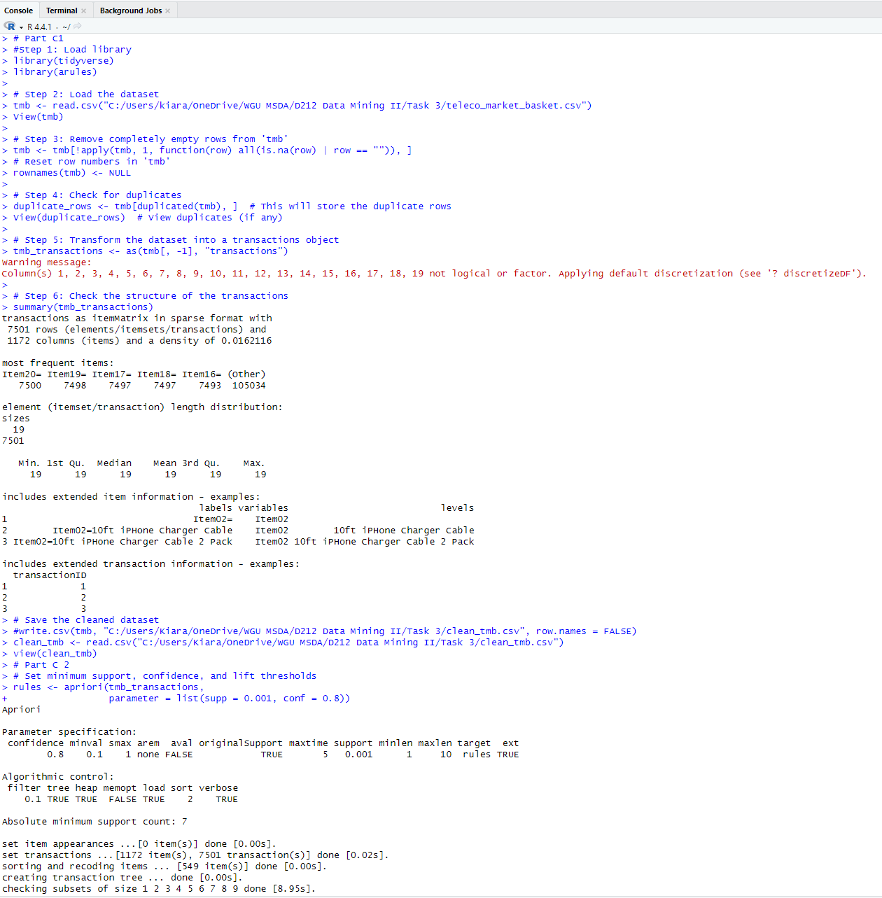
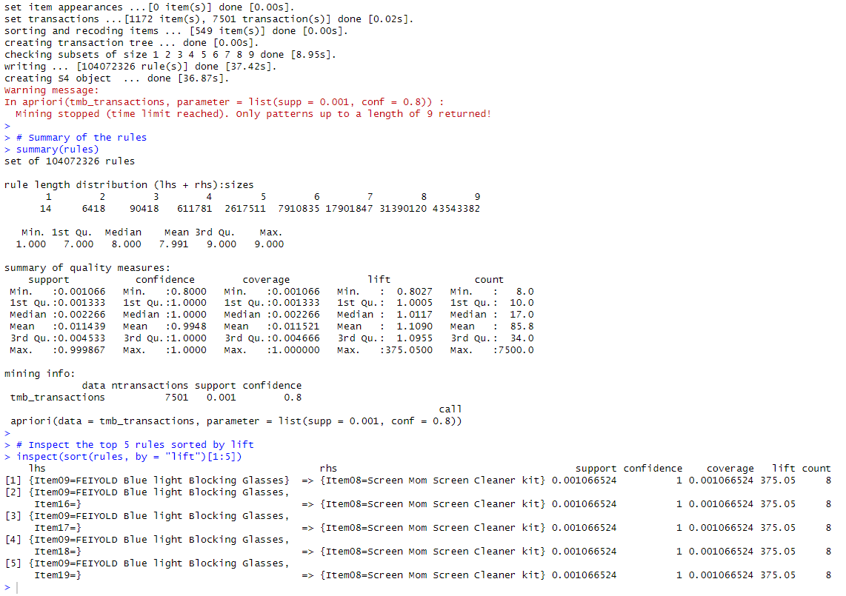

Provided Values of the Association Rules Table
The values of the association rules table is broken down as follows:
Support: “refers to the proportion of transactions that contain both the lhs and rhs items” (R Market Basket Analysis using Apriori Examples, 2018)
- For the top rule, the support is 0.0011 which is about 8 transactions out of 7501
Confidence: “refers to the proportion of transactions that contain the rhs item given that they also contain the lhs item”
- The confidence for these rules is 1, meaning that every time the LHS items are purchased, the RHS item is also purchased.
Lift: “is a measure of how much more likely the rhs item is to be purchased when the lhs item is also purchased, compared to the probability of purchasing the rhs item without considering the lhs item” (R Market Basket Analysis using Apriori Examples, 2018)
- The lift for the top rule is 375.05, meaning there is a very strong association between these items.

The Apriori Algorithm’s Top 3 Relevant Rules
The top three relevant rules are:
- If "FEIYOLD Blue light Blocking Glasses" is purchased, then "Screen Mom Screen Cleaner kit" is also purchased.
Support: 0011 = 8 Transactions
Confidence: 1 = 100% of the time, these items are bought together
Lift: 375.05 = These items are bought together 375 times more frequently than would be expected by chance
- If "FEIYOLD Blue light Blocking Glasses" and " 3A USB Type C Cable 3 pack 6FT" are purchased, then "Screen Mom Screen Cleaner kit" is also purchased.
Support: 0.0011 8 transactions
Confidence: 1 = 100% of the time, these items are bought together
Lift: 375.05 = These items are bought together 375 times more frequently than would be expected by chance
- If "FEIYOLD Blue light Blocking Glasses" and " HOVAMP iPhone charger" are purchased, then "Screen Mom Screen Cleaner kit" is also purchased.
Support: 0.0011 8 transactions
Confidence: 1 = 100% of the time, these items are bought together
Lift: 375.05 = These items are bought together 375 times more frequently than would be expected by chance
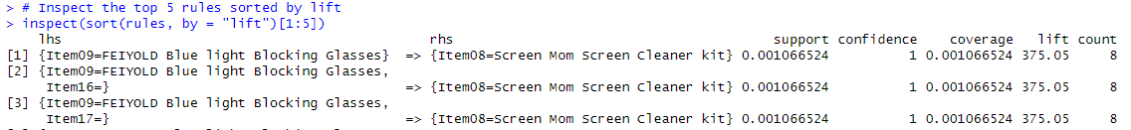

Part IV: Data Summary and Implications

Summarize Data Analysis

Significance of Support, Lift, and Confidence:
Support: Support tells us how often specific item combinations show up in the data. For example, with a support of 0.0011, I know that the combo of "FEIYOLD Blue Light Blocking Glasses" and "Screen Mom Screen Cleaner Kit" was bought in 8 out of the 7501 transactions. This is important because it shows me how frequently these two items are paired. The more they are bought together, the more likely they should be paid attention to for marketing or product placement ideas.
Confidence: Confidence shows how reliable the relationship between items are. For this analysis , the confidence is 1.0, which means every time the glasses are bought, the screen cleaner is bought too. That’s 100% of the time, which is important information. So, if someone buys the glasses, we can feel very confident that they’ll grab the cleaner too.
Lift: Lift measures the strength of the association compared to random chance. With a lift of 375.05, I am looking at a big association between these two items. That means they’re 375 times more likely to be bought together than by random chance. Lift is major because it highlights which item pairs are really worth focusing on, especially when it's that high.

Practical Significance of Findings:
The practical significance of these findings is the strong association between certain items, which can be used to inform marketing and product placement strategies. Like, the fact that "FEIYOLD Blue Light Blocking Glasses" and "Screen Mom Screen Cleaner Kit" have high support, confidence, and lift means that bundling these items or placing them near each other in online or physical stores could increase sales. By promoting these items together in targeted ads or offering discounts on them as a package deal can help enhance customer engagement and encourage purchases.

Recommended Course of Action:
My recommendation course of action based on this analysis, to create Product Bundles, Improve Product Placement, Inventory Management and Targeted marketing. For example, we can create bundles of "FEIYOLD Blue Light Blocking Glasses" and "Screen Mom Screen Cleaner Kit", makes sure those items are always in stock, place them next to each other at stores or side by side online and when creating ads have those items together. This will help the company make the best of the two items partnership and improve sales with something that is already working.

Part V: Attachments

Panopto Video

Link: Ganger, Kiara Task 3 D212 (panopto.com)

References
Apriori Algorithm in R Programming. (2021, August 20). Retrieved from GeeksforGeeks: https://www.geeksforgeeks.org/apriori-algorithm-in-r-programming/
R Market Basket Analysis using Apriori Examples. (2018, August 21). Retrieved from DataCamp: https://www.datacamp.com/tutorial/market-basket-analysis-r

